

**中原大學 雲端計算平台實務**

**12/17-作業報告**

**Microsoft Azure AI Fundamentals: Explore visual tools for machine learning**

**資訊四乙 10727211 林彥輝**

**授課教師：鍾武君 教授**

**中華民國一一○年十二月**

# Learning Path Intro

**Microsoft Azure AI Fundamentals: Explore visual tools for machine learning**

https://docs.microsoft.com/en-us/learn/paths/create-no-code-predictive-models-azure-machine-learning/

# Summary Homework Assignment

## Model 1: Use automated machine learning in Azure Machine Learning

1. Create a Azure Machine Learning workspace

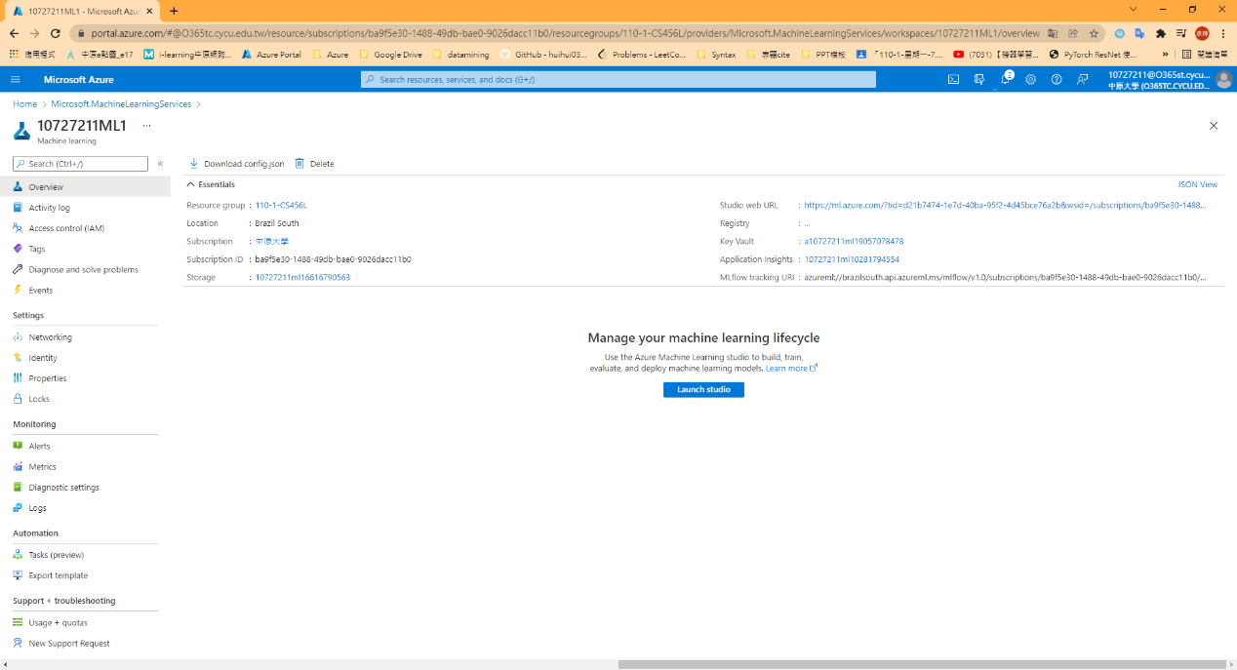

1. Create compute resource

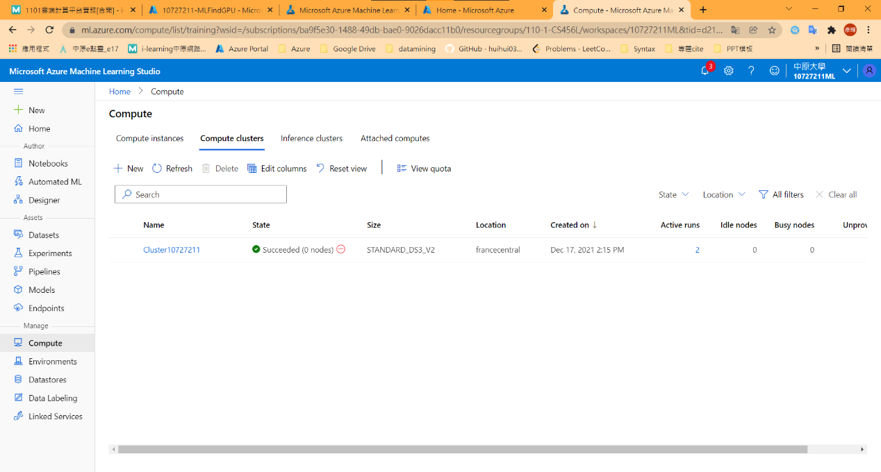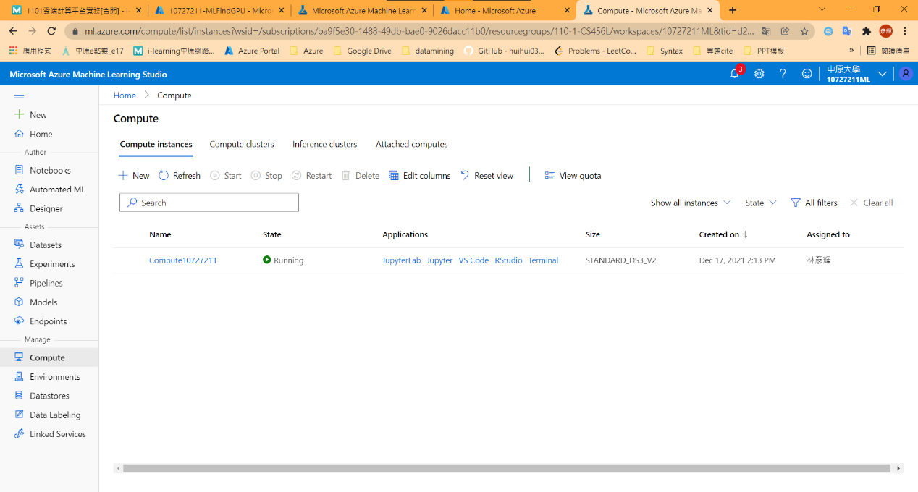

1. Create a dataset

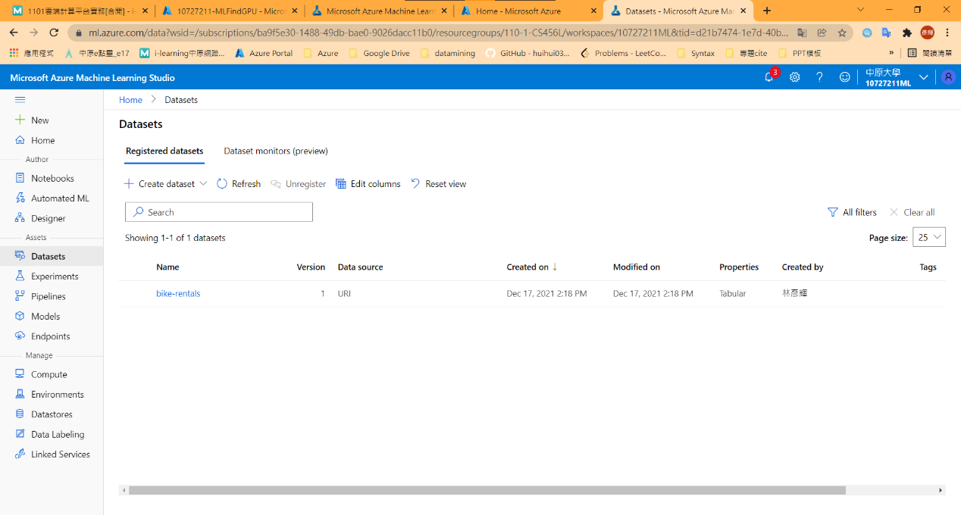

1. Run an automated machine learning experiment

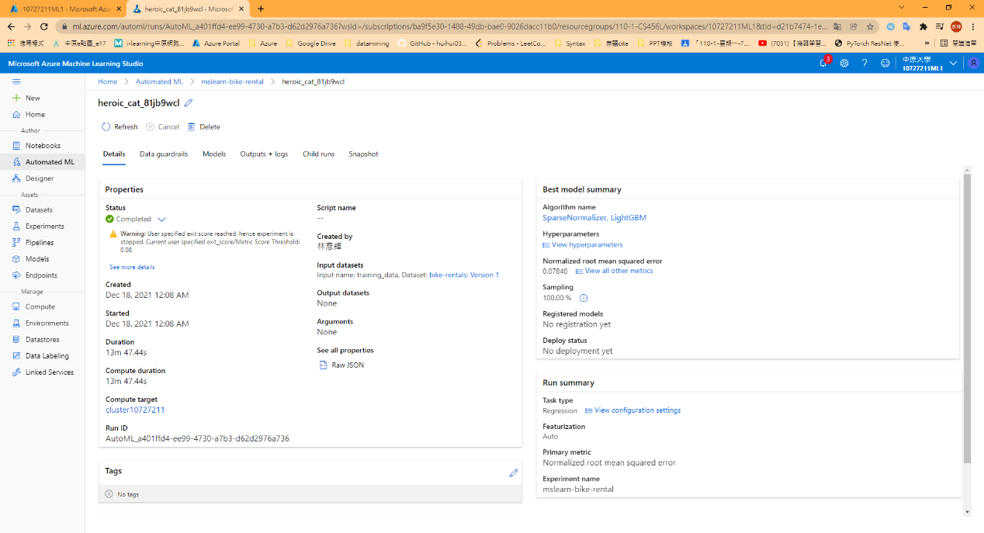

1. Review the best model

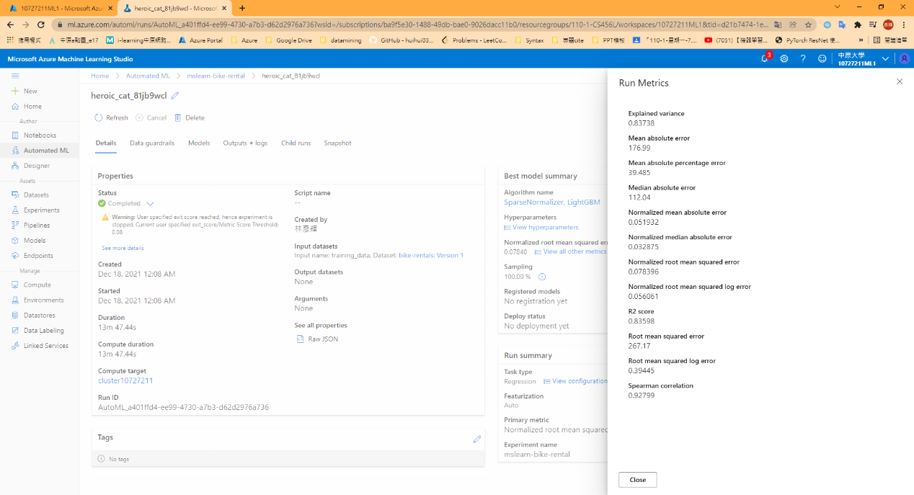

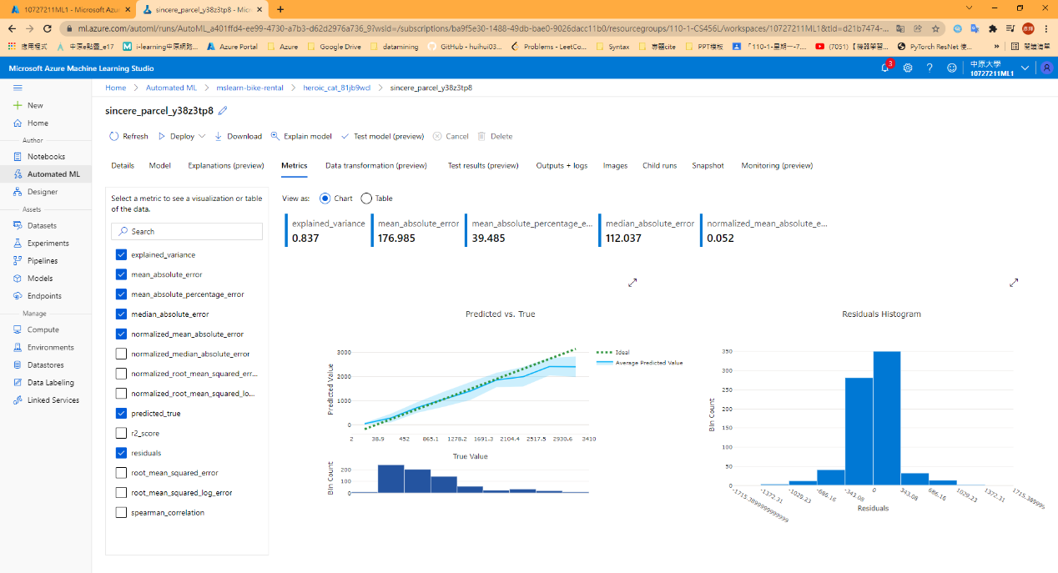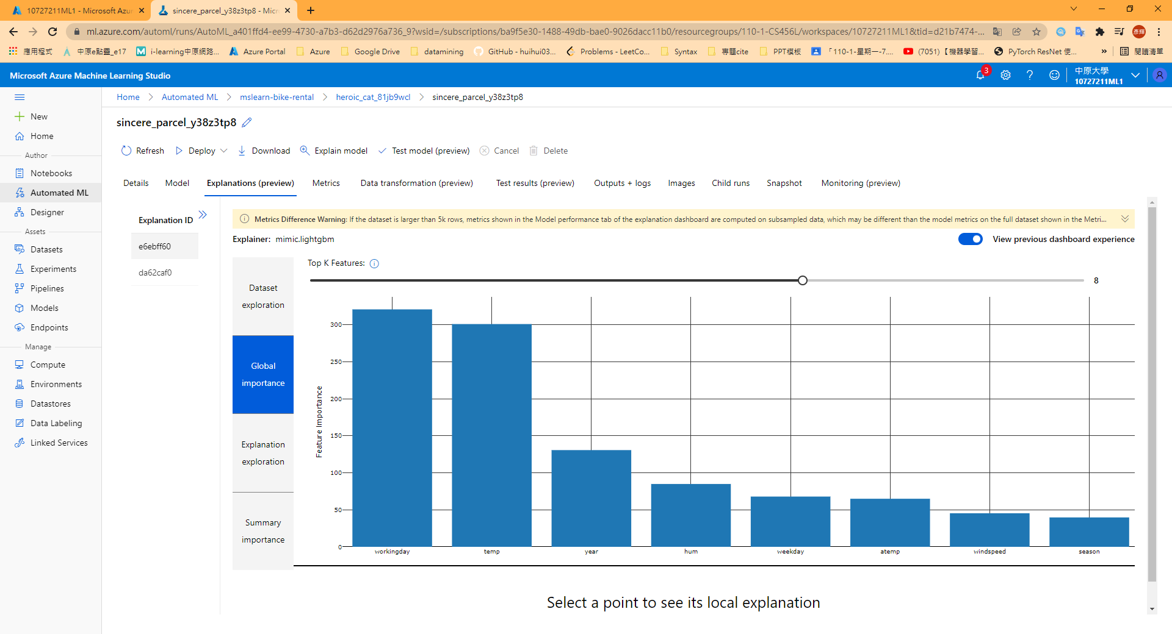

1. Deploy a model as a service

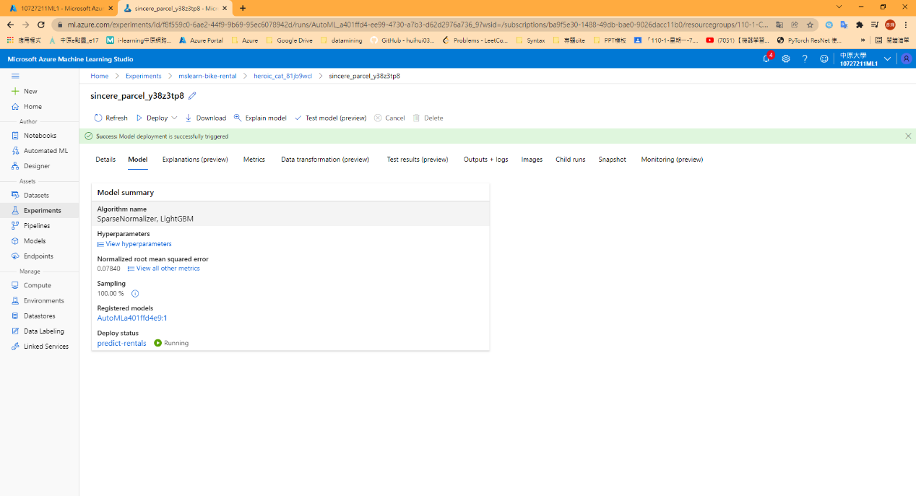

1. Test the deployed service

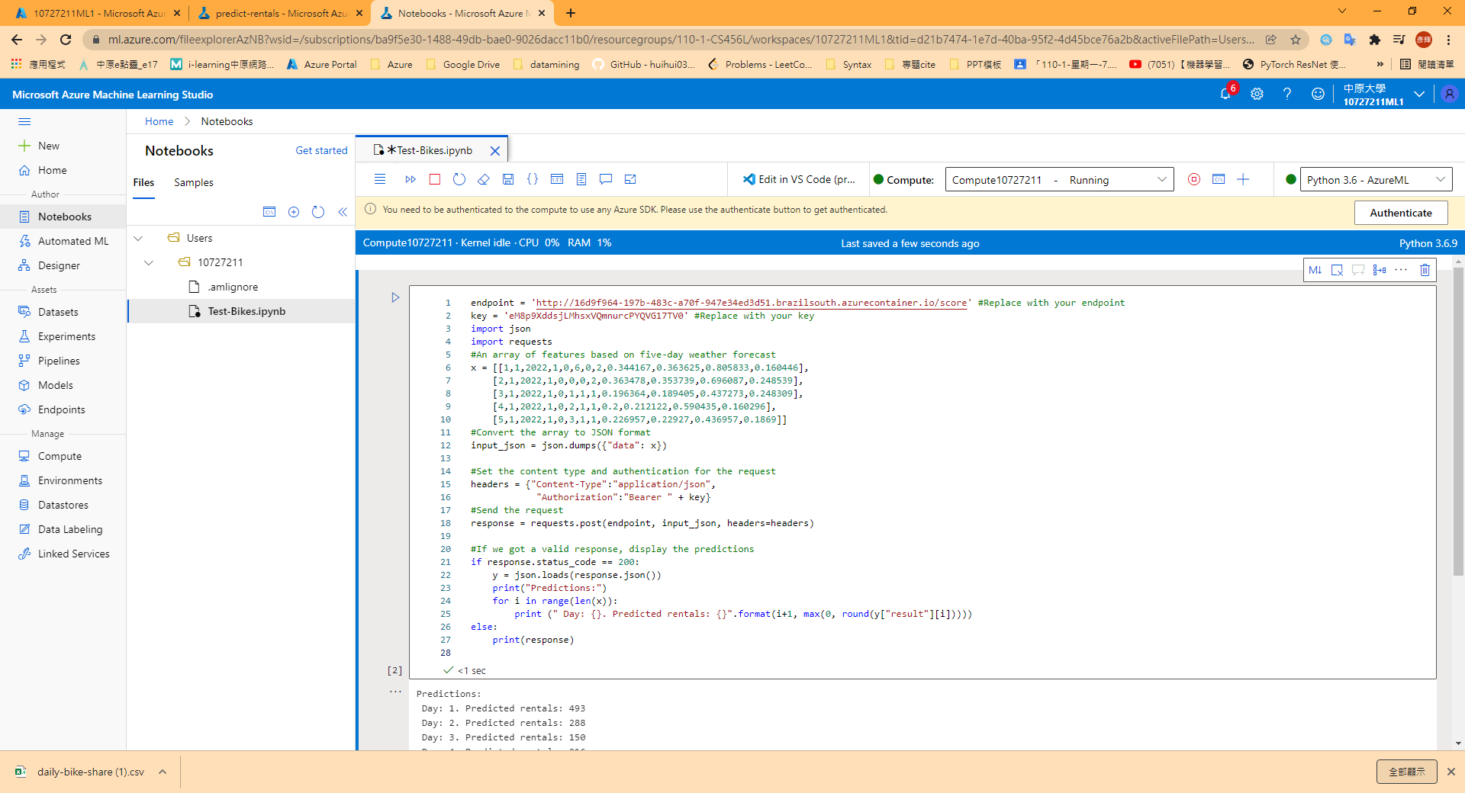

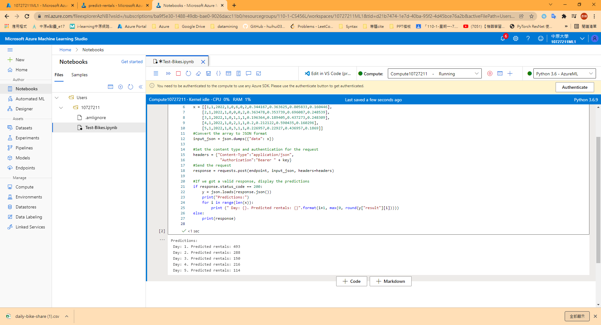

## Model 2:Create a Regression model with Azure Machine Learning designer

1. Create pipeline & Add and explore dataset & Run pipeline

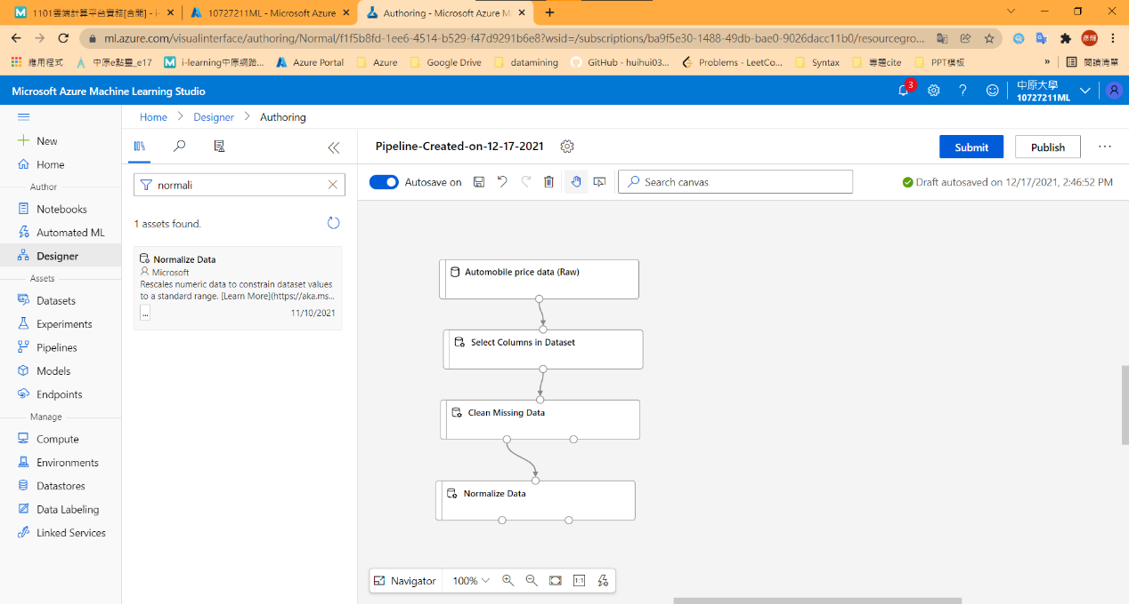

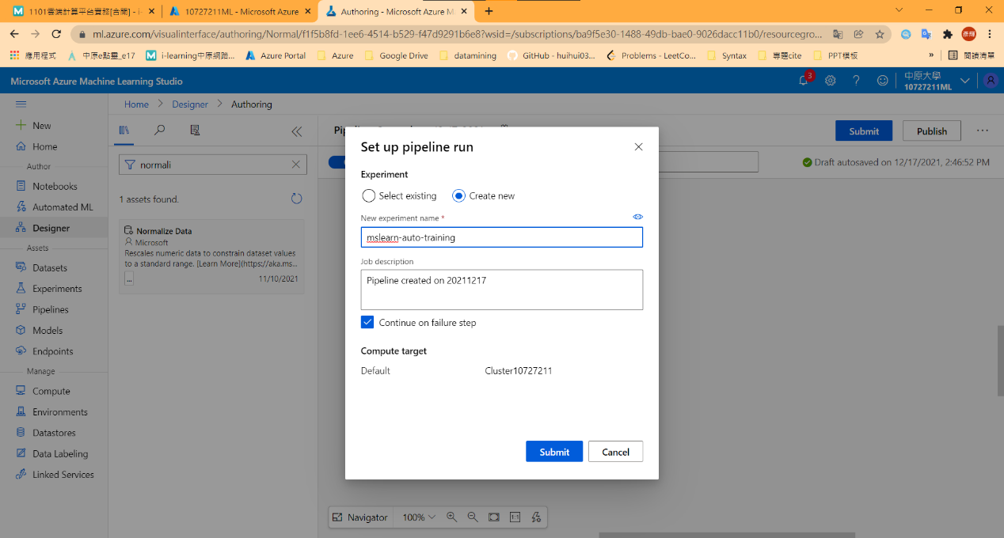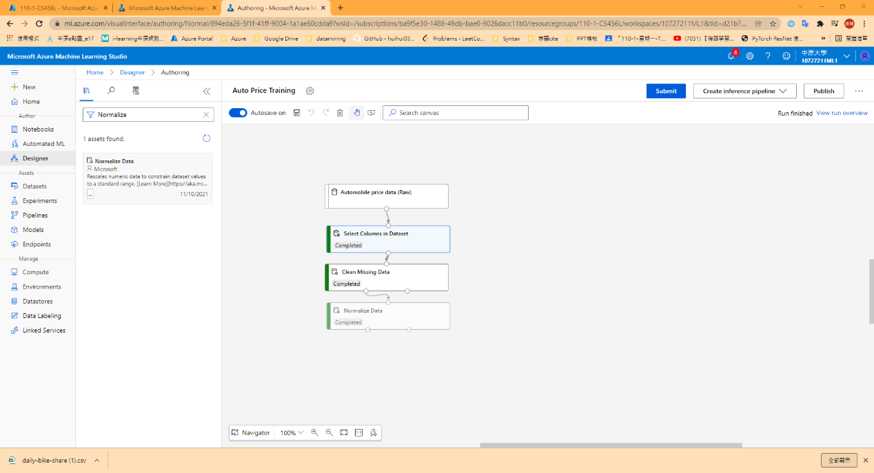

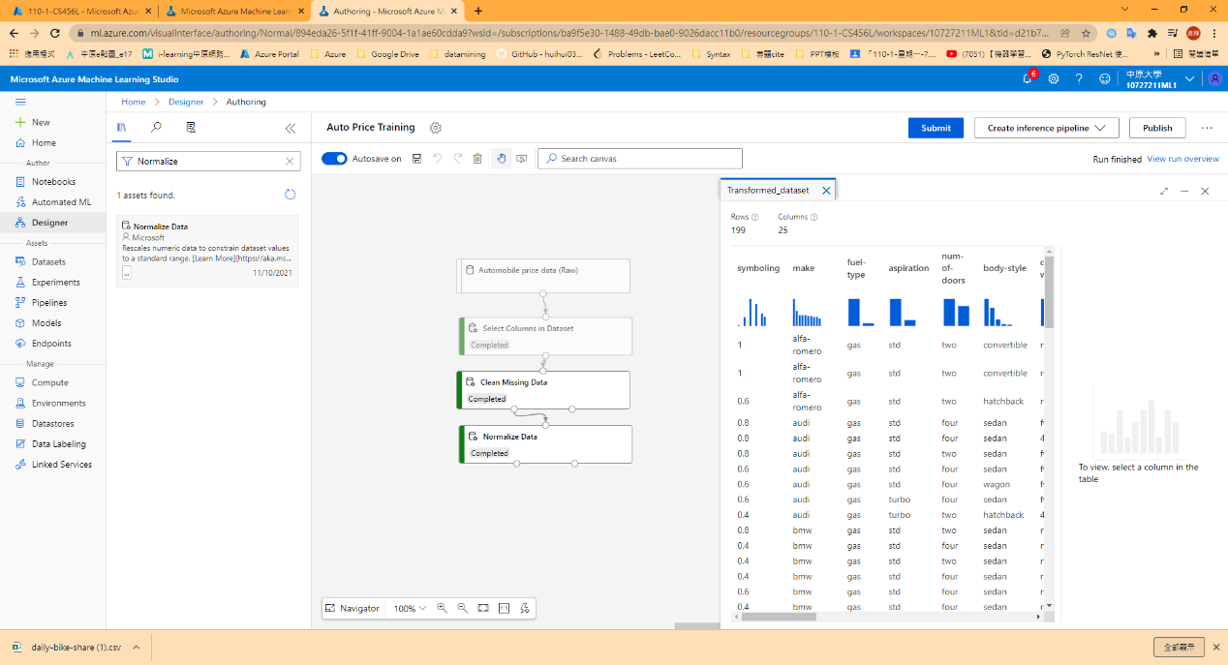

1. Create and run a training pipeline

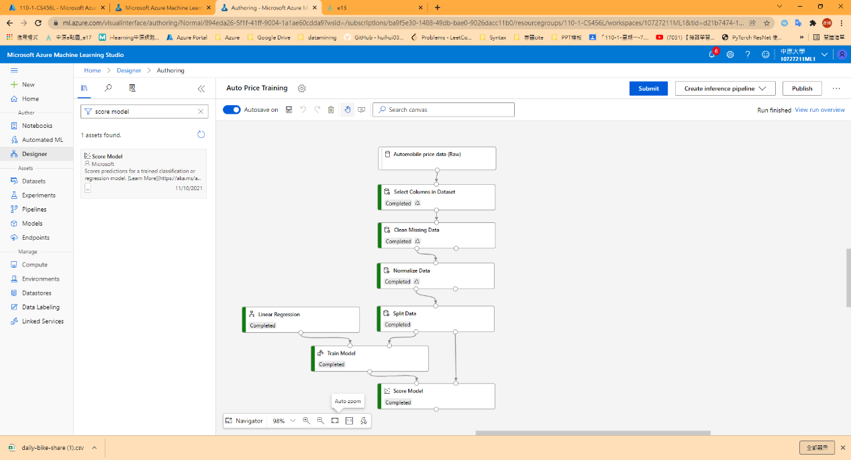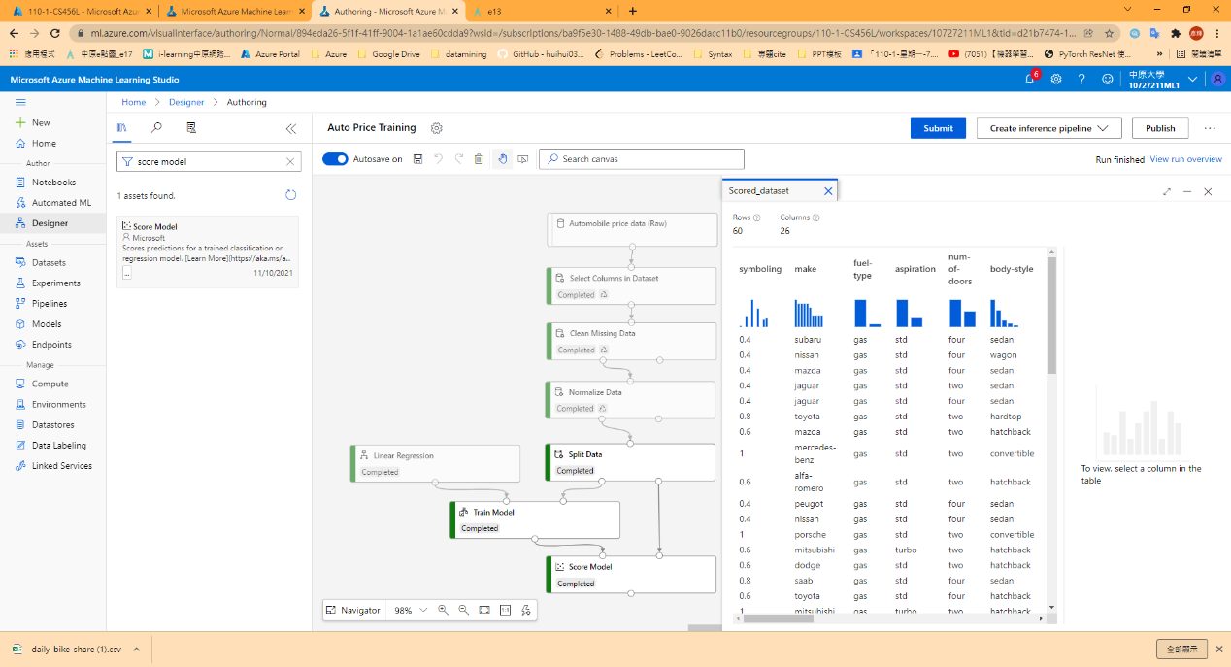

1. Evaluate a regression model

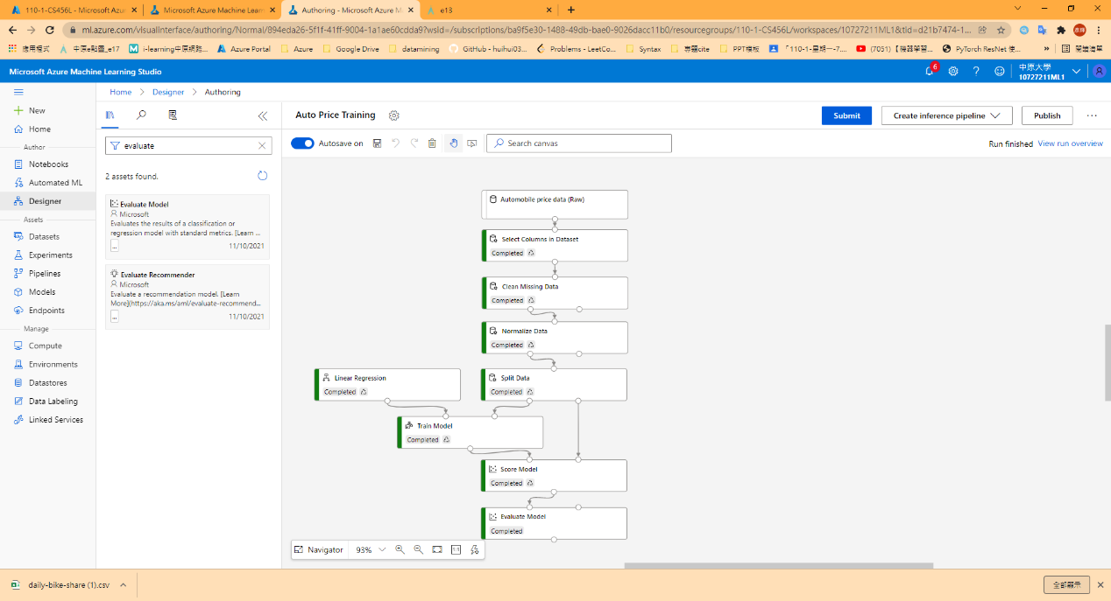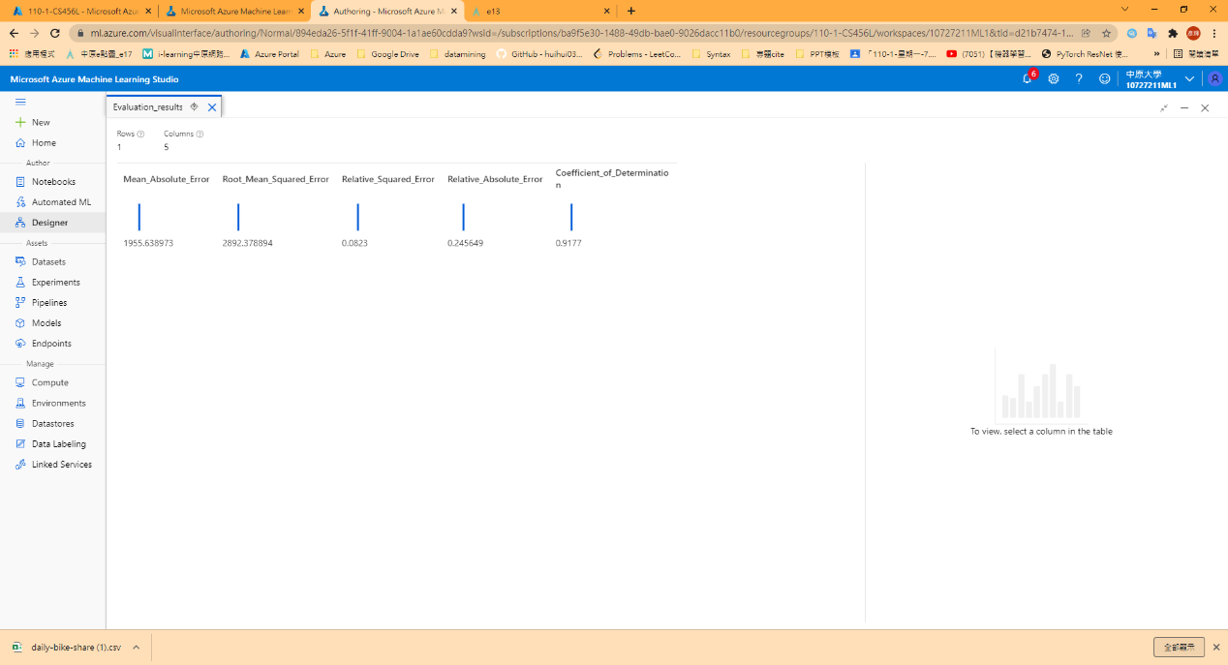

1. Create and run an inference model

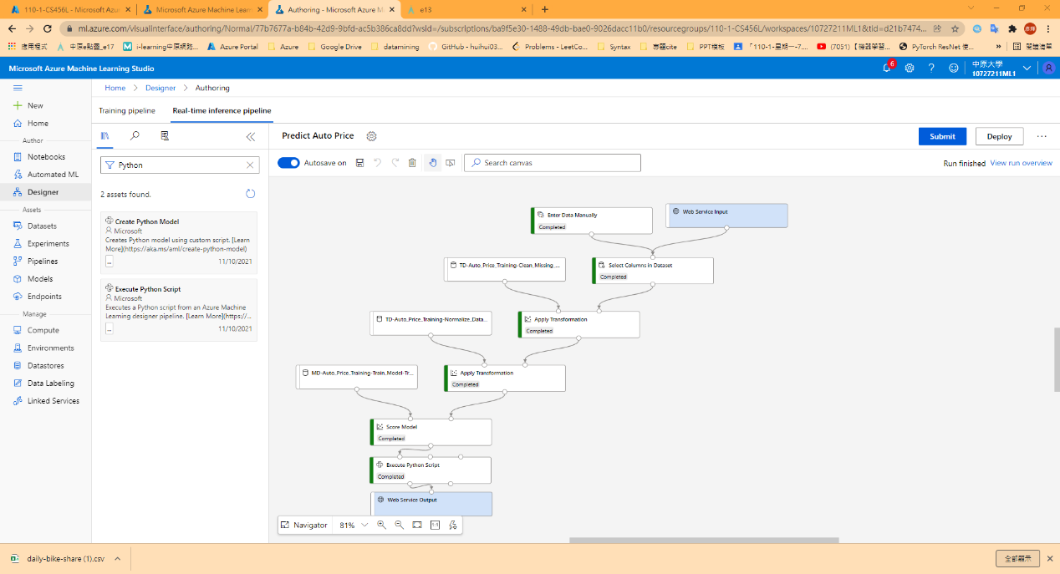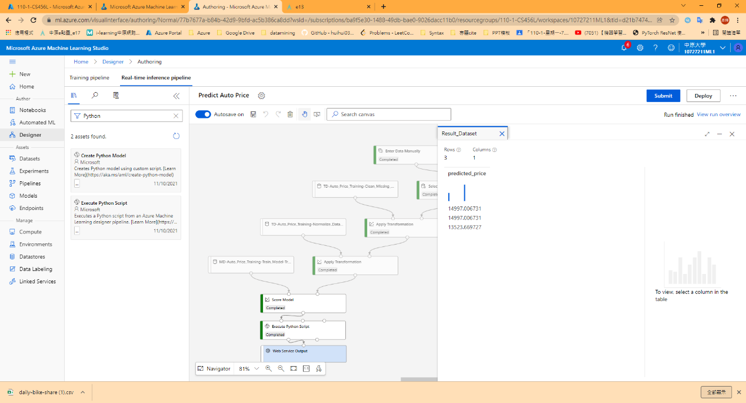

1. Deploy a predictive service & Test the service

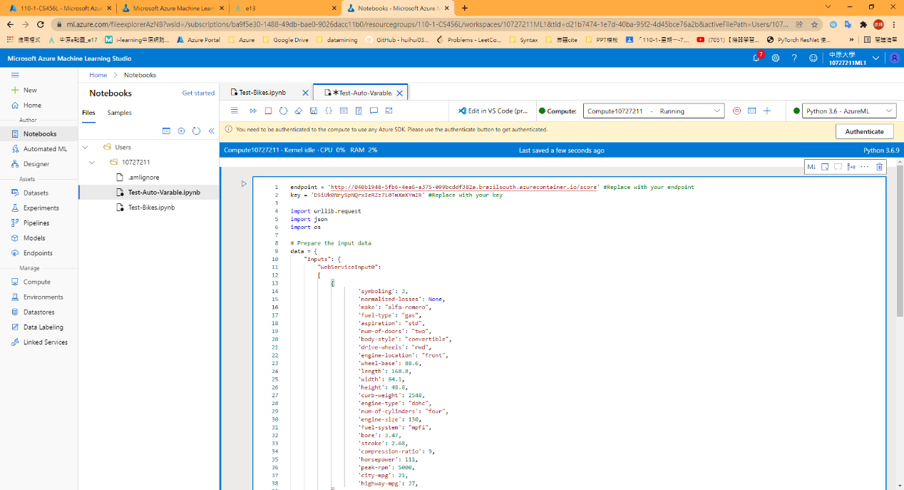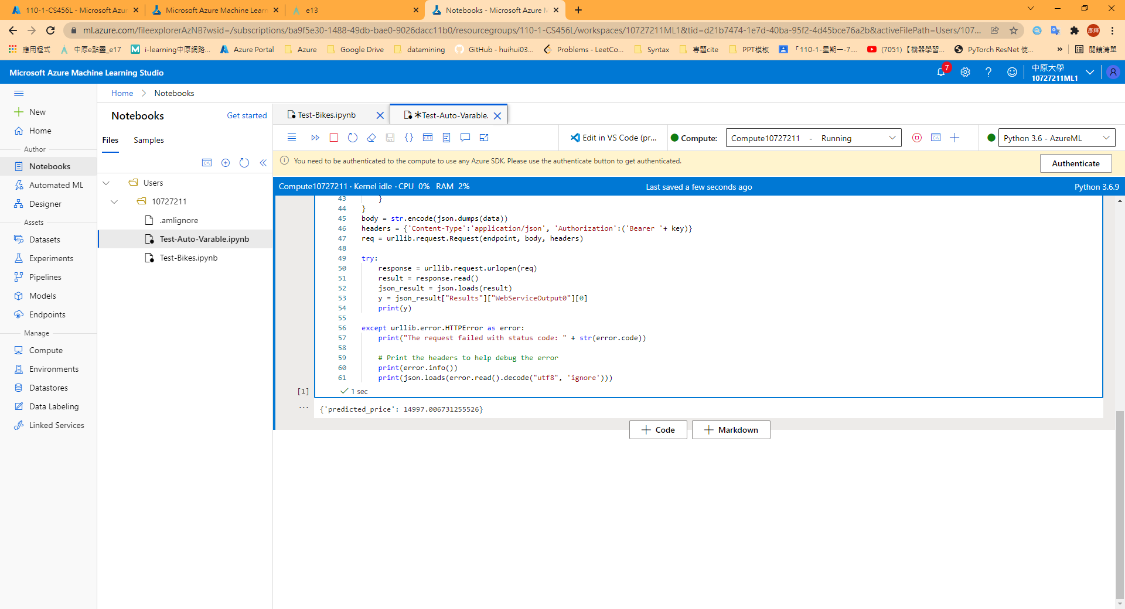

## Model 3:Create a classification model with Azure Machine Learning designer

1. Create a dataset

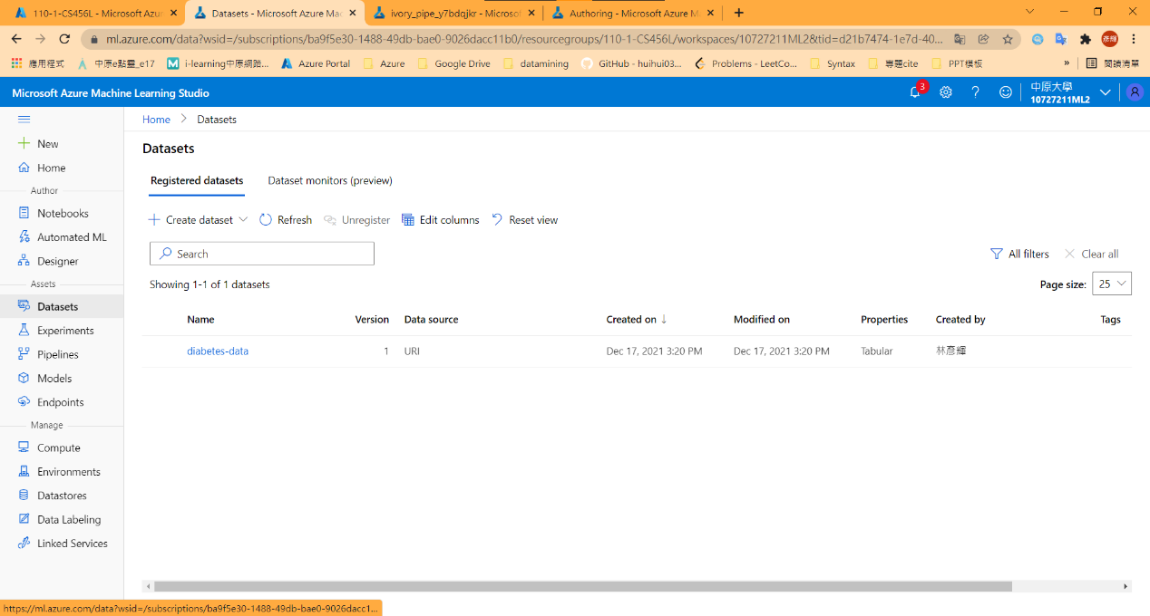

1. Create a pipeline & Add Transformations

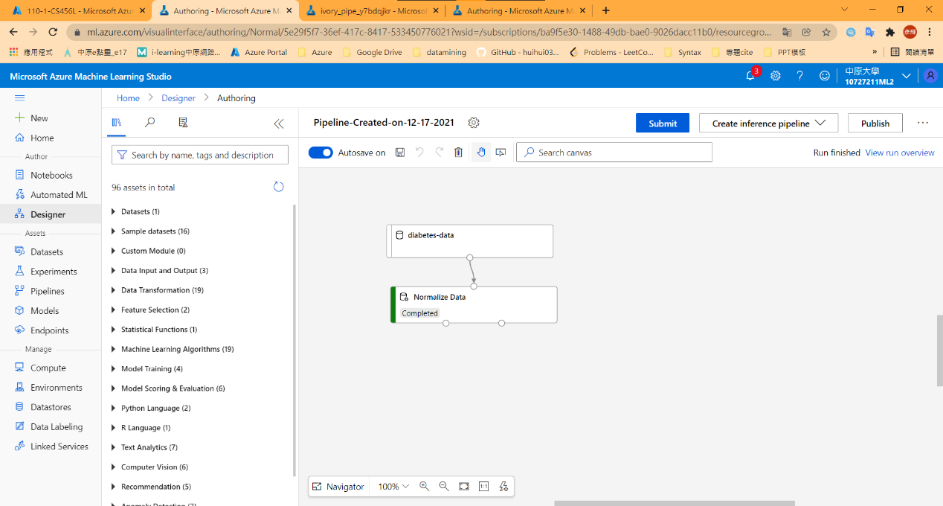

1. Run the pipeline & View the transform data

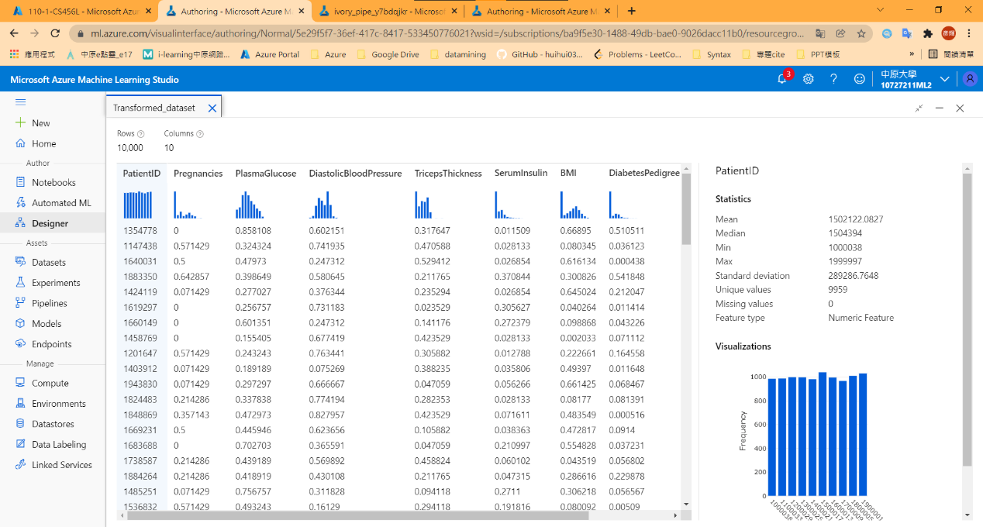

1. Add training models

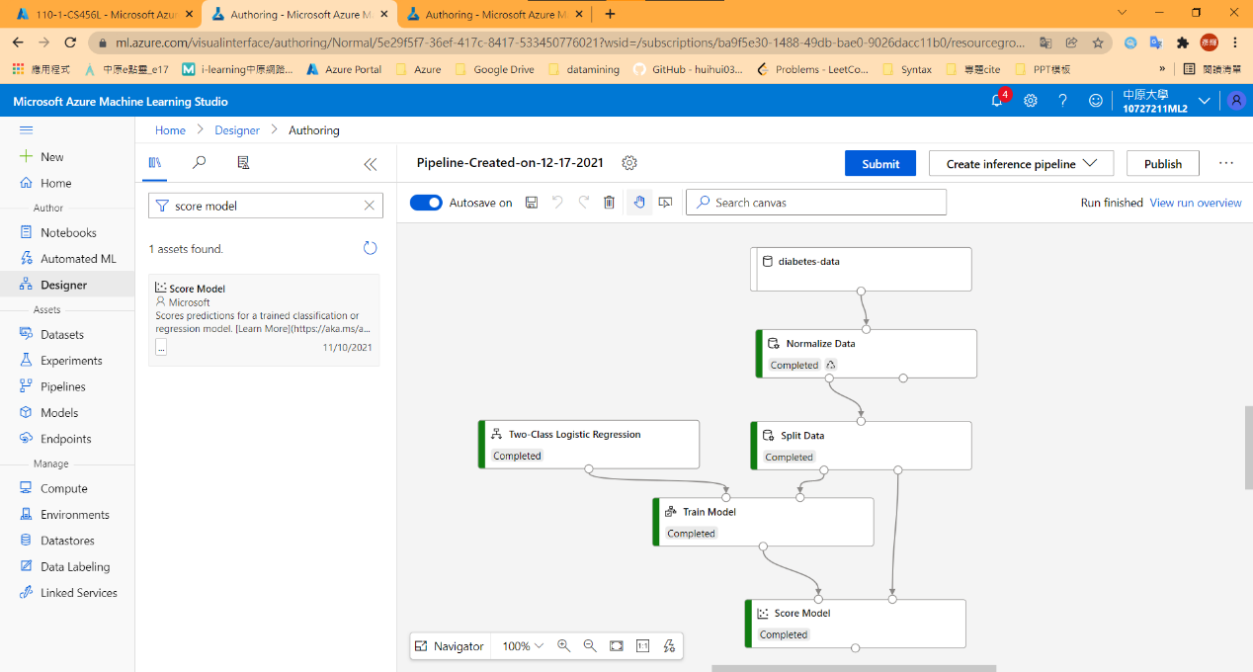

1. Run the training pipeline & View result

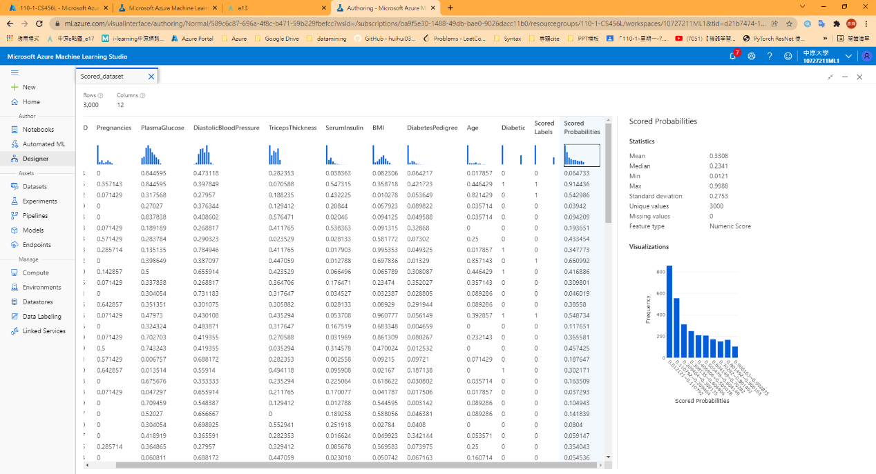

1. Add an evaluate model

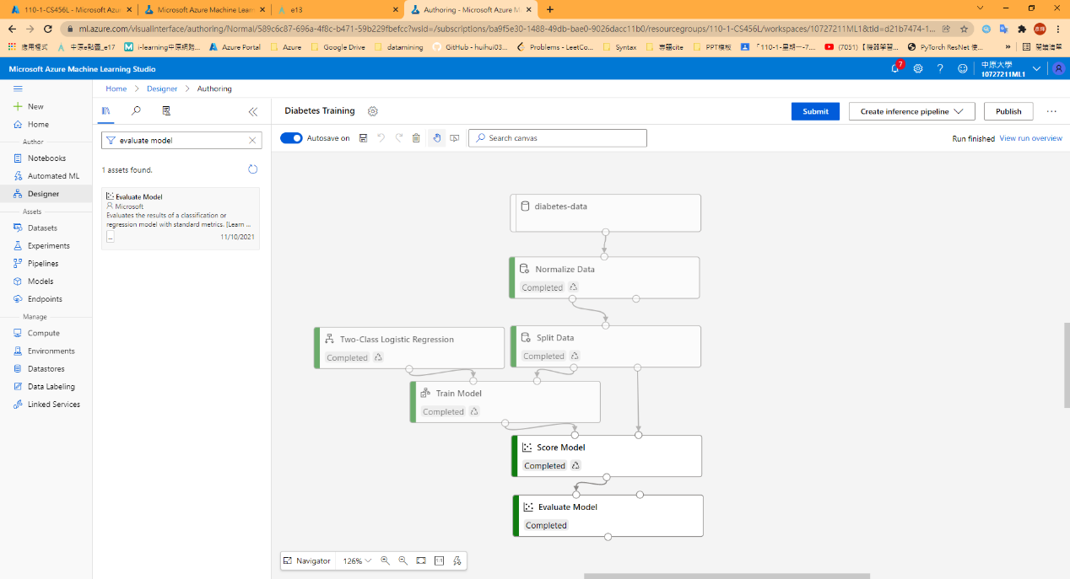

1. View Result

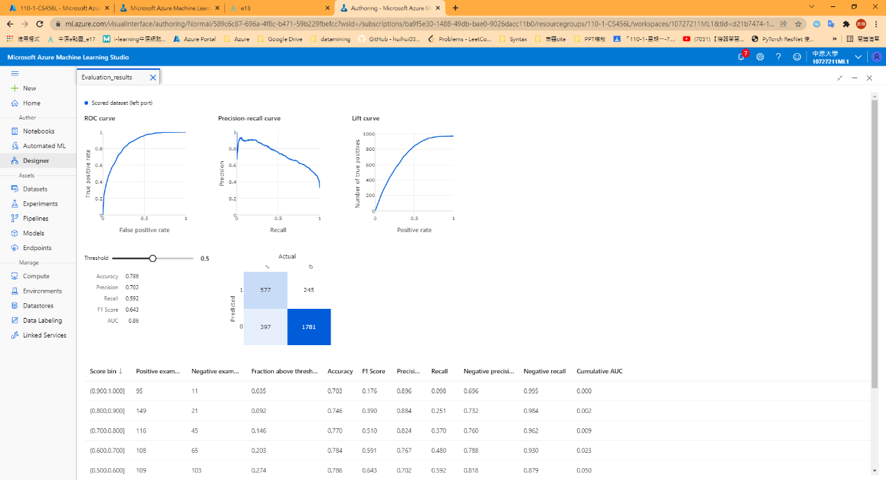

1. Create an inference pipeline

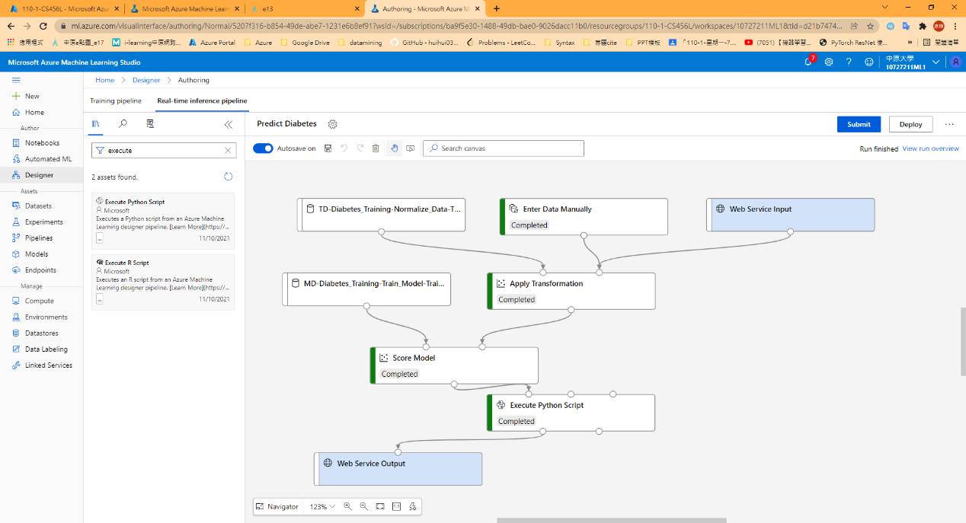

1. Run the pipeline & View result

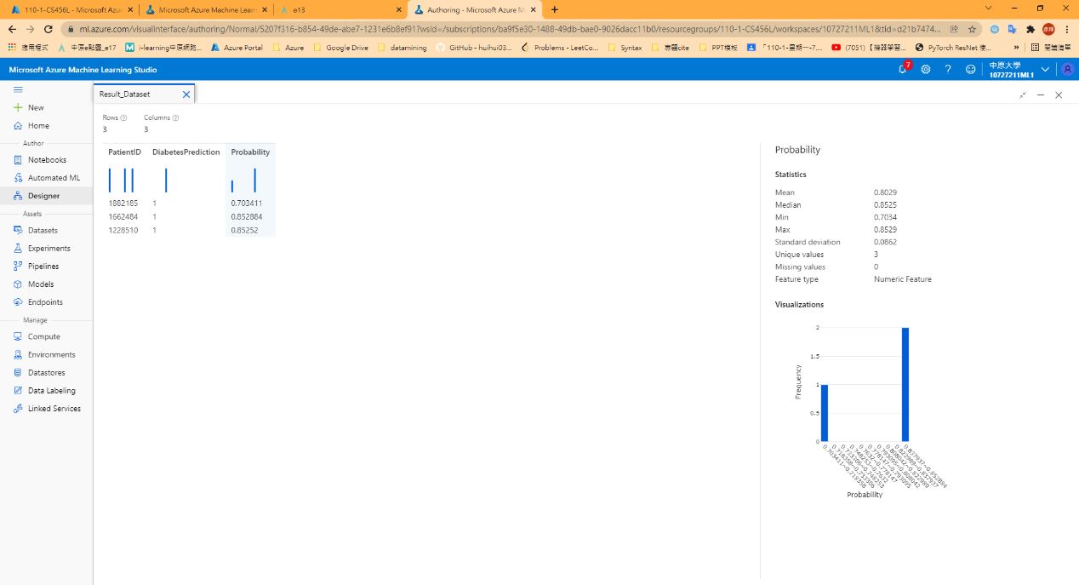

1. Deploy a service & Test the service

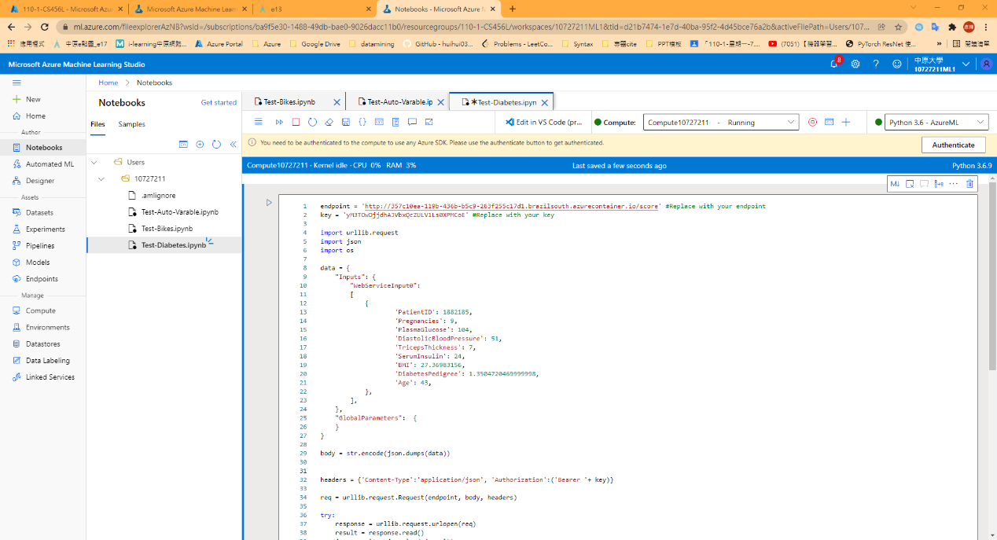

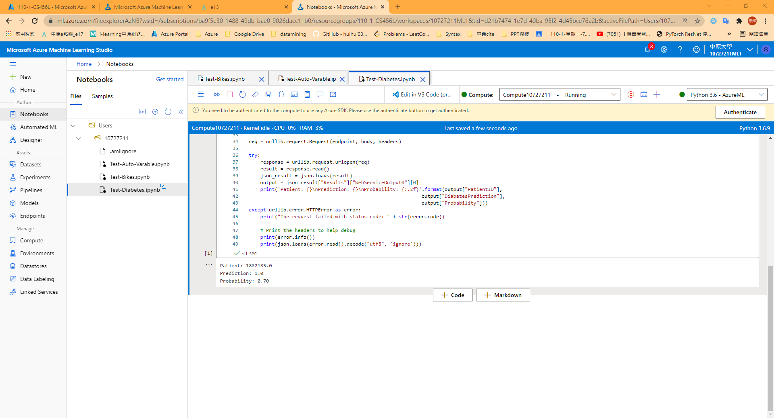

## Model 4:Create a Clustering model with Azure Machine Learning designer

1. Create a dataset

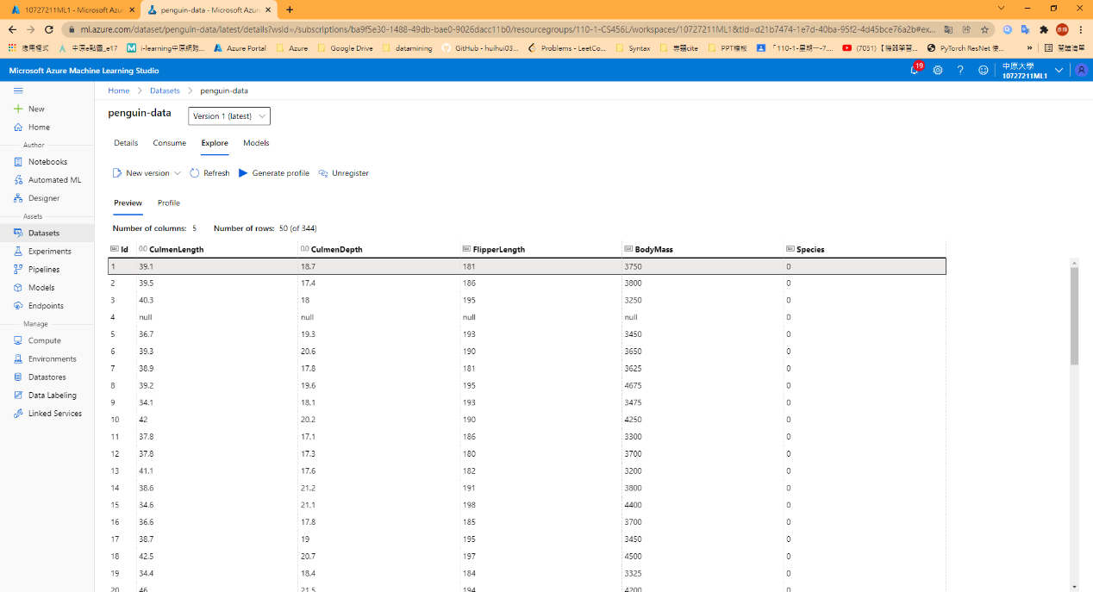

1. Create a pipeline & Apply Transformations

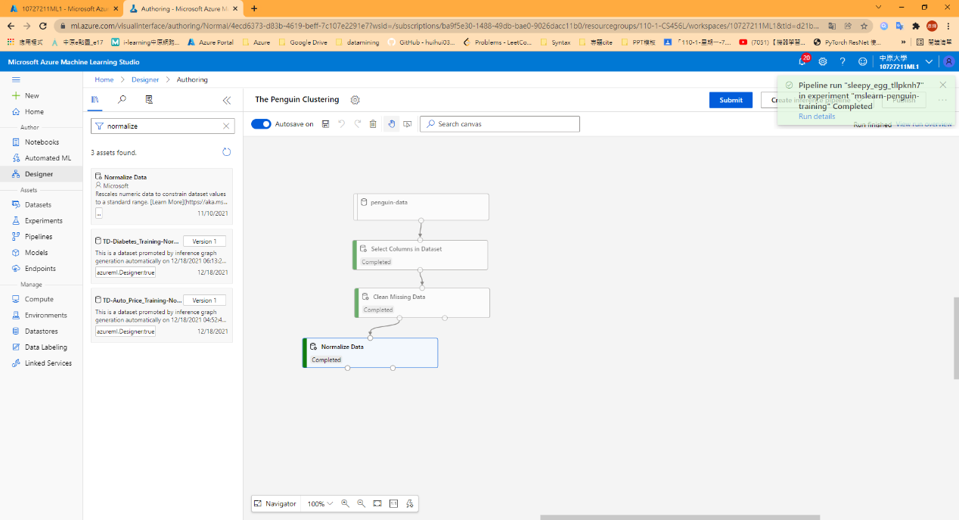

1. View the transformed data

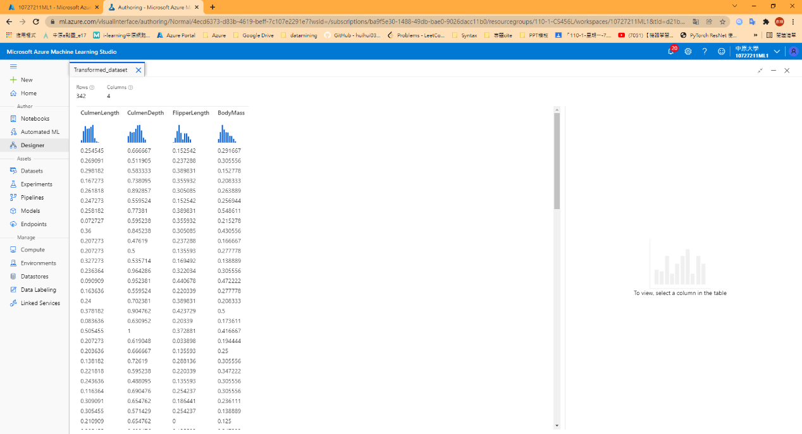

1. Add training models

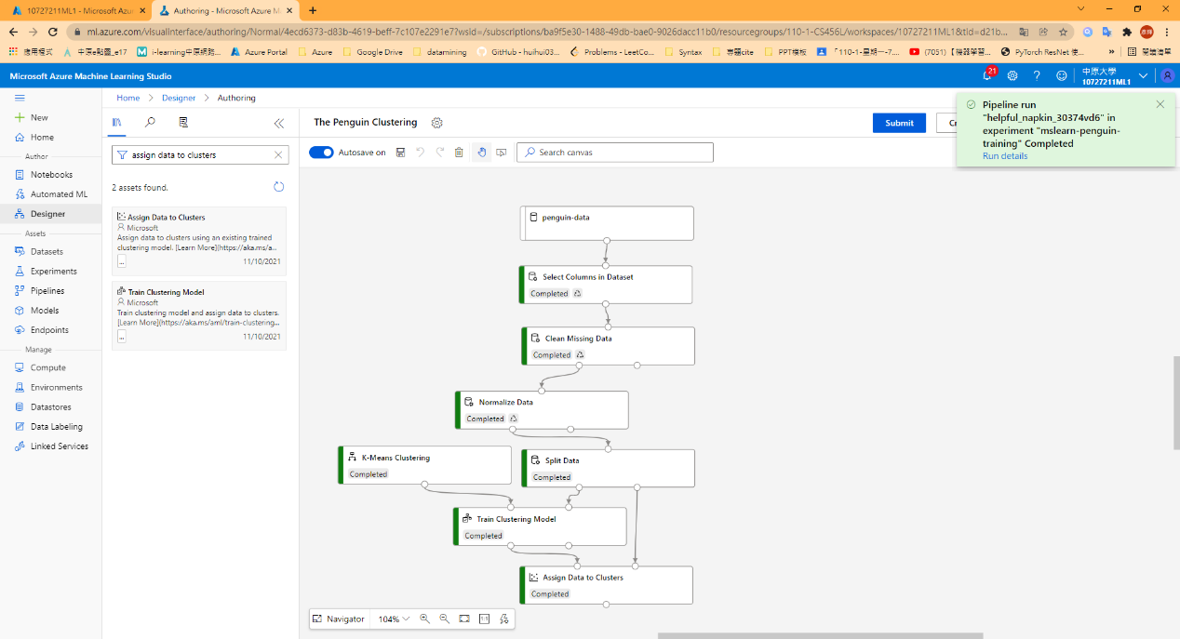

1. Run the training pipeline & View results

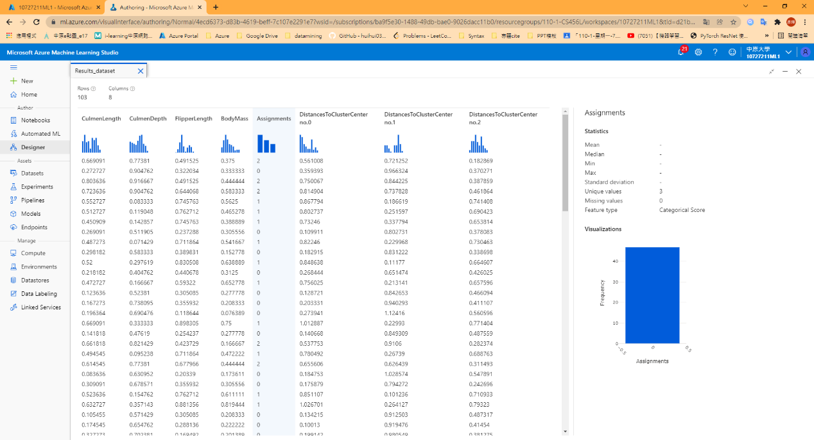

1. Add and Evaluate Model

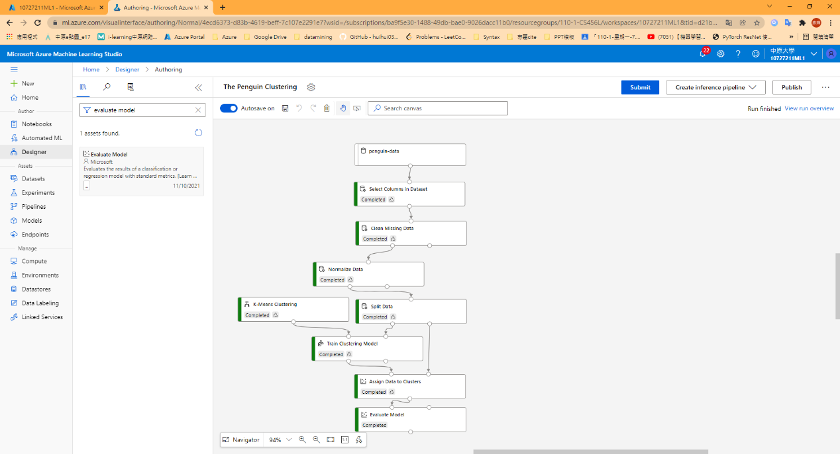

1. View Result

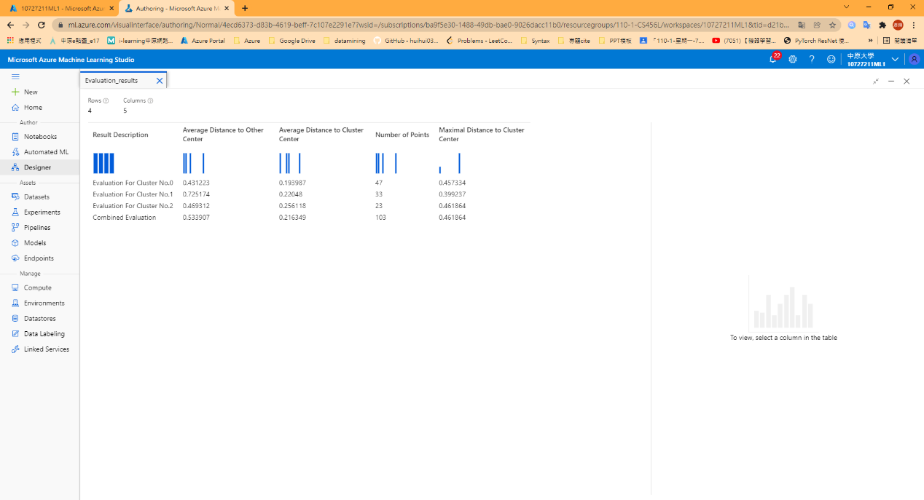

1. Create an inference pipeline

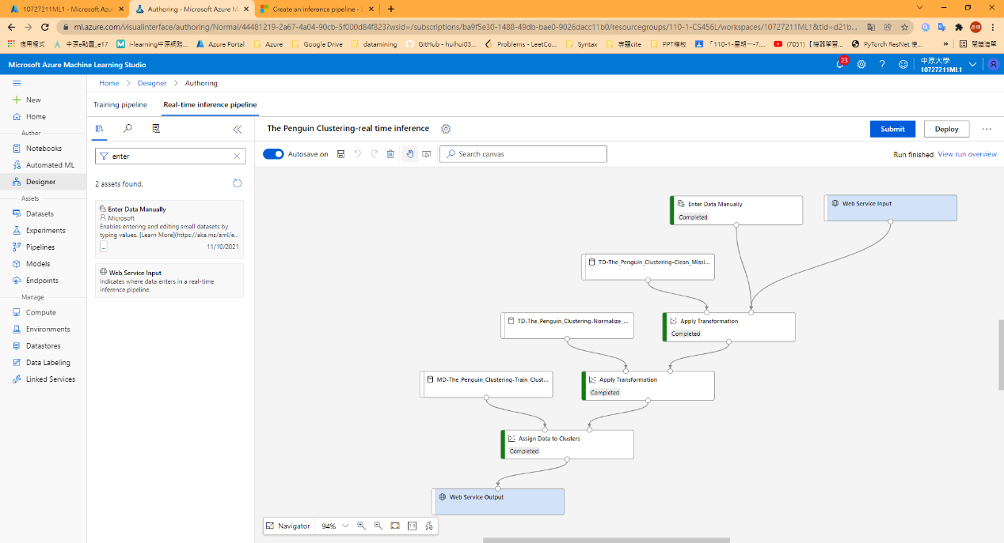

1. View Result

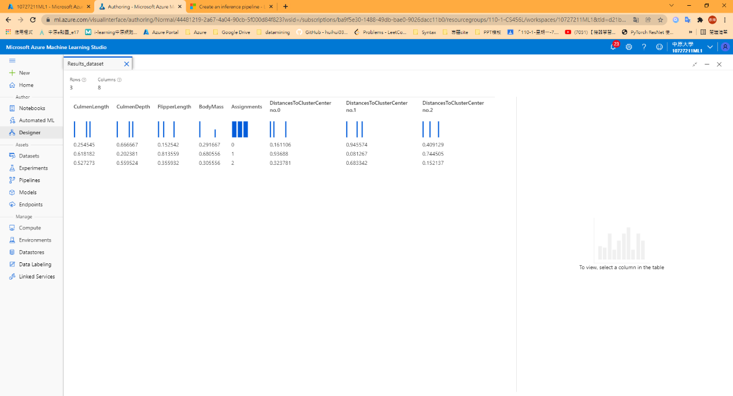

1. Deploy a service and test the service

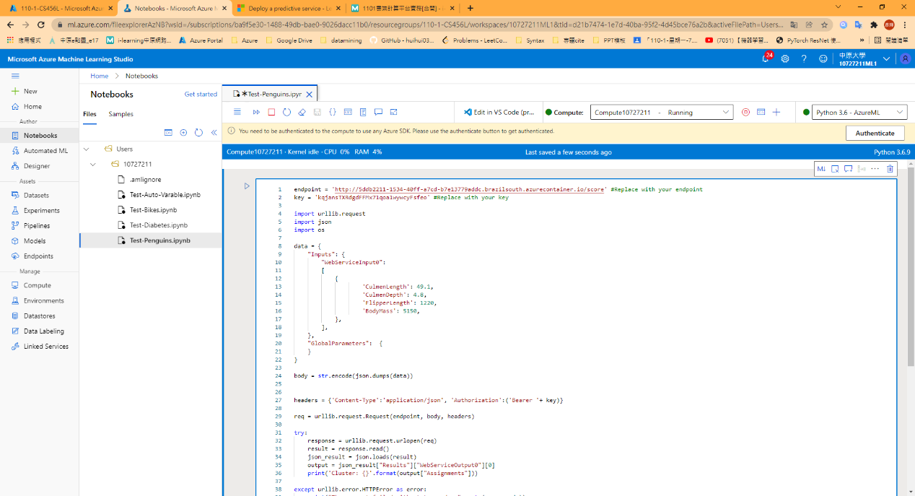

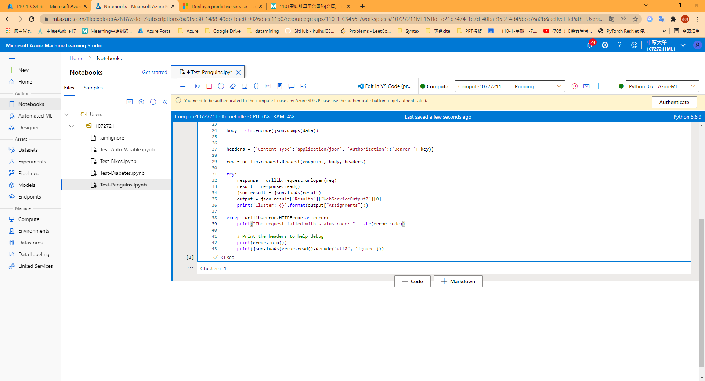

## Take screenshots of Badges and Trophies

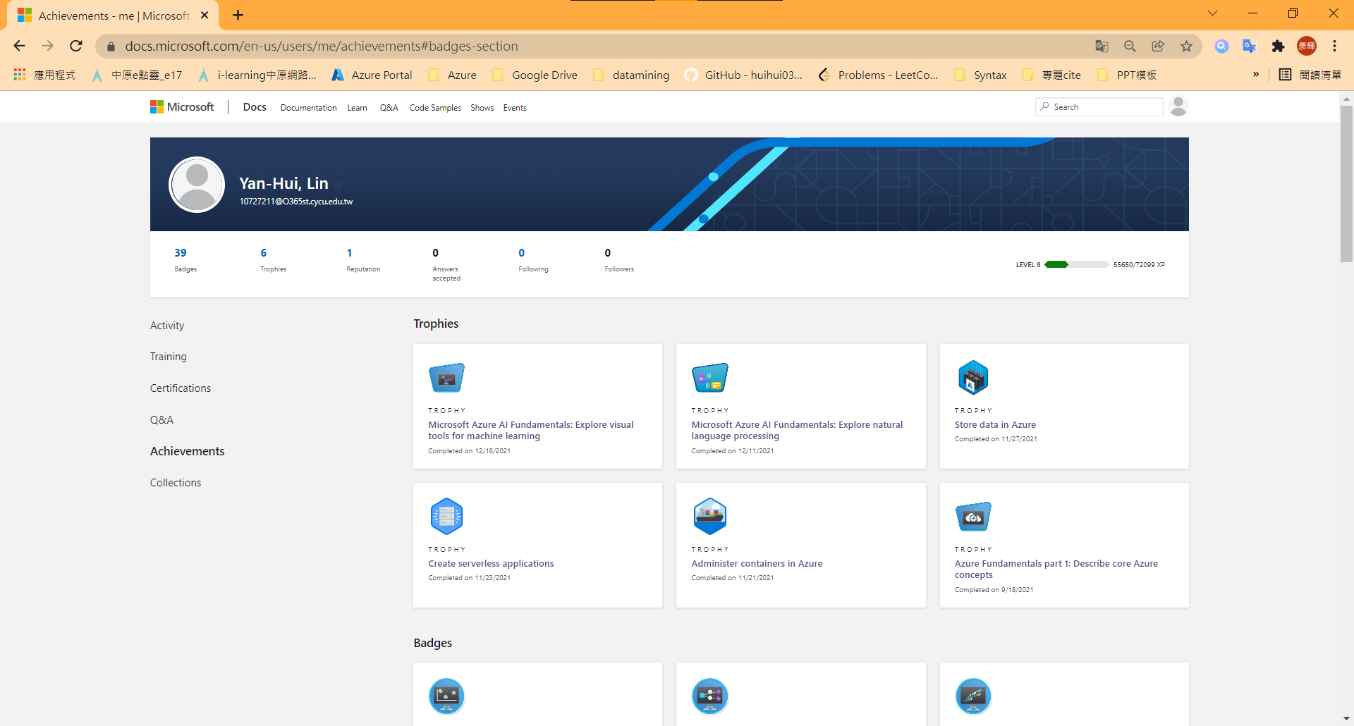

## Learned from the Learning Path

Azure Machine Learning在機器學習中提供相當多的參數，從計算資源、演算法、GUI介面、部署方式、計算模型、驗證模型到分析模型，Azure的ML提供的計算相當多元，不管是資料前處理、模型訓練、驗證、甚至圖表分析都有Model支援，且分析的結果數據相當多元。Pipeline的GUI概念讓開發人員可以更專注於他們的開發工作，Learning Path過程中也從中習得不少ML的演算法知識與驗證觀念。

# Problems

1. 部分的Region可能資源不夠，Run Model時可能因Training時間過長而導致系統主動判斷Timeout Error。
2. 可以考慮開啟GPU模式（所有的地域都無法看見可用GPU之資源）。

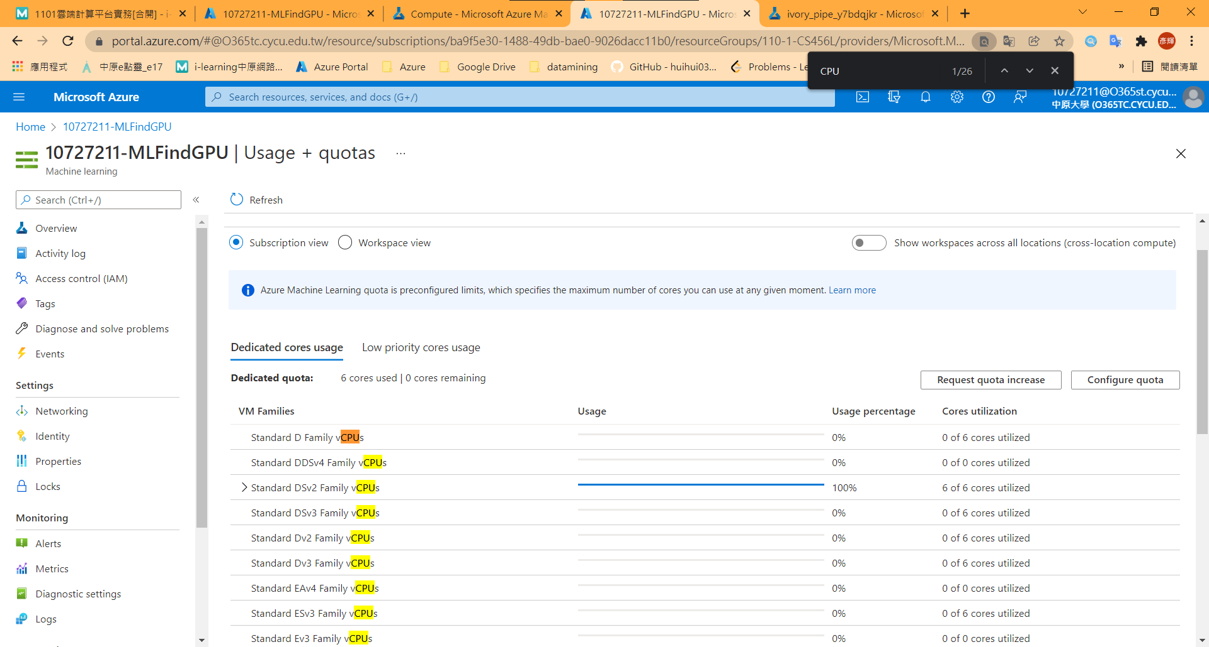

# FeedBack

透過Azure Machine Learning的Pipeline，從中體認Azure對於「No Code」支援的強大，使用者可以將實作需要的理論透過GUI Block的方式實作想要的應用，且這些GUI也支援防呆機制，在Pipeline IO加入審查機制，讓使用者可以減少Debug的過程，Azure提供的演算法也相當多元，最後也可以透過GUI將Model做部署至Container Instance供及時Inference、Predict，供對於機器學習的初心者而言，Azure Machine Learn是一個相當適合的環境。